**Original Visualization**

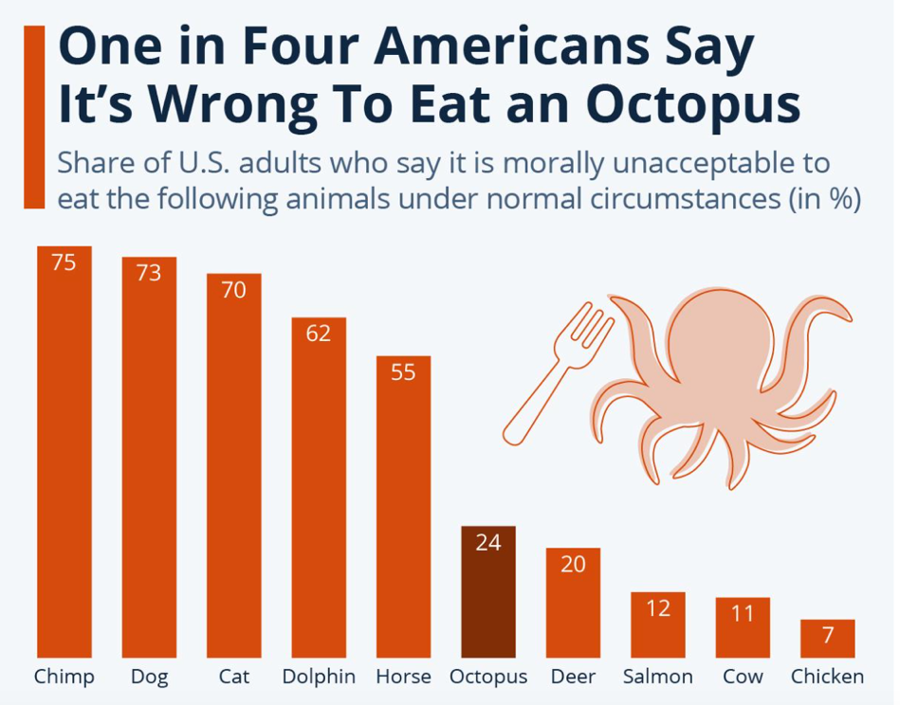

**My Visualization**

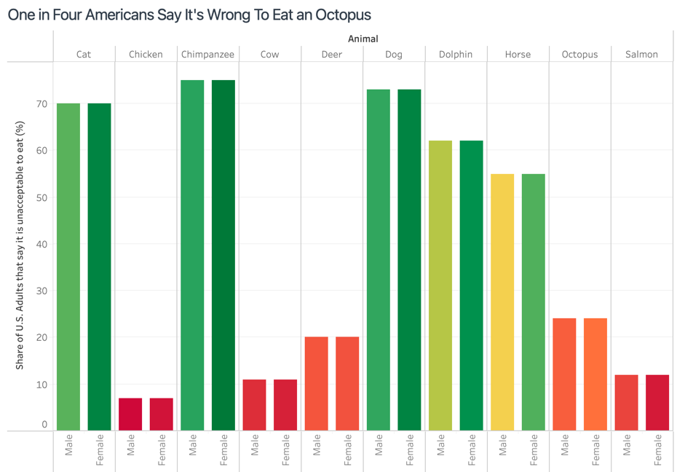

**Changes**

1. Added sex genres
2. Added colors

**Explanation**

For my approach I decided to add the Male vs Female to make it clearer and specific on the % of unacceptable to eat. As I mentioned in the changes I added colors to make the graph brighter and colorful because the original one looks plain and simple. I didn’t change the bars graphic because I think it fits accordingly to the metrics of the visualization.